<https://www.youtube.com/watch?v=MEX6pUdPdfo&list=PLSw2mlMYG5MJd7UUZmH0T87_VmjT-qpEy&index=9&ab_channel=ProgrammingAndrew>

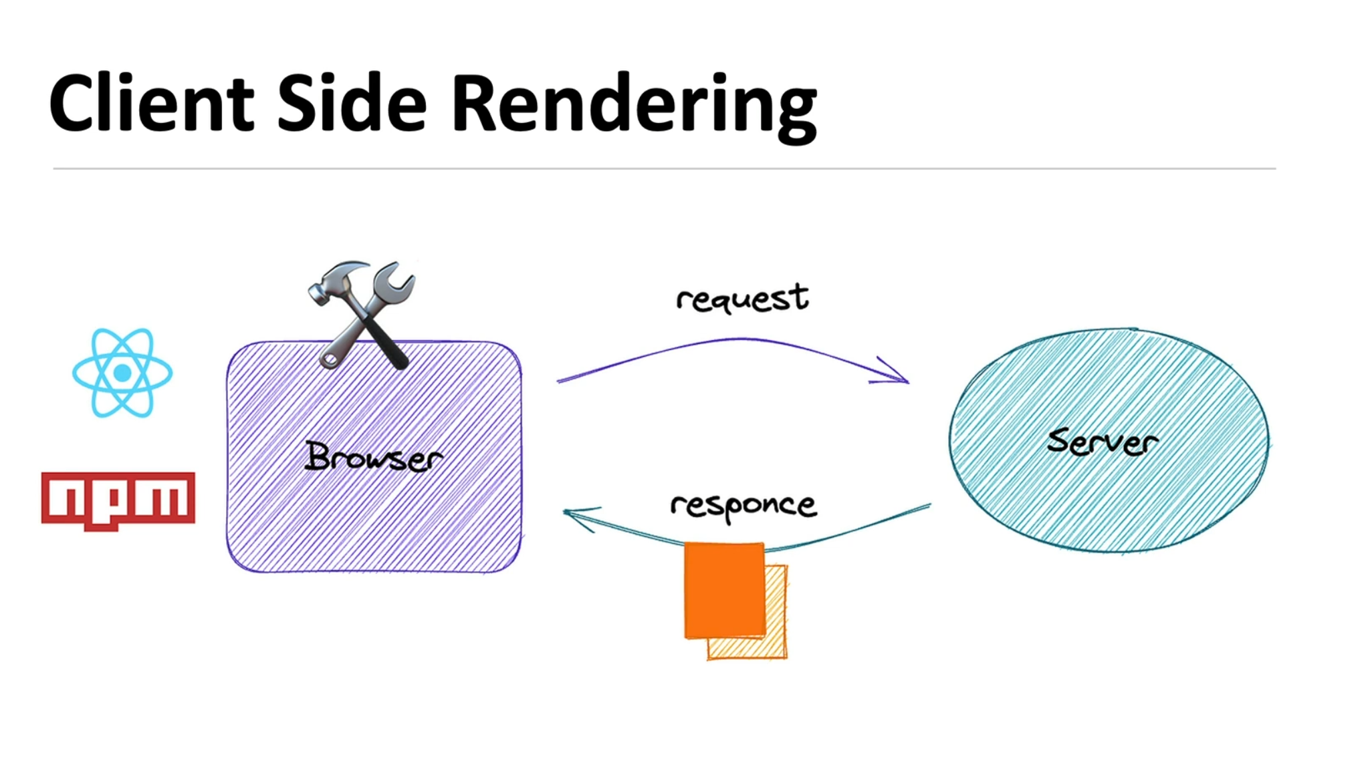

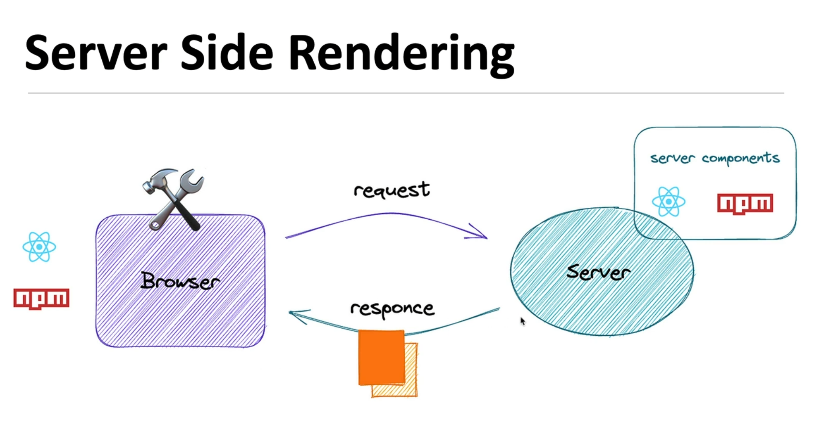

nextJS預設的是server Component

要和用戶交互的就要設計成Client Components其他部分都用Server Component

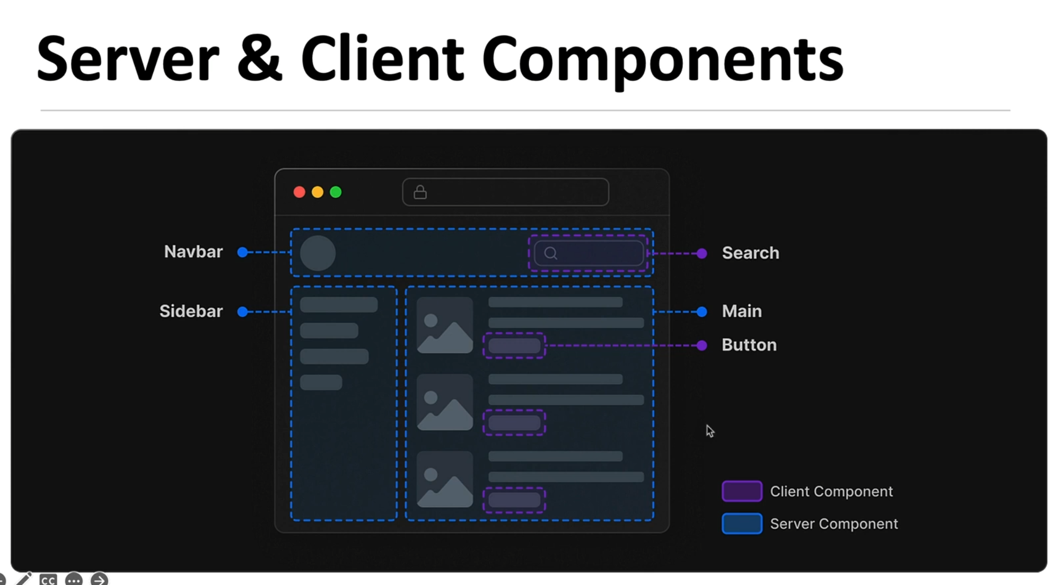

要設定成 client Component要用

“use client”;

